**Homework 2, Astro 289, Winter 2020**

**Due Thursday January 30th**

**Problem 1)** Atmospheric coherence length and isoplanatic angle 

Evaluate the atmospheric coherence length and the isoplanatic angle  for the following three turbulence profiles. For each turbulence profile, showand  for two wavelengths: 0.5 μm and 2 μm. Be sure to state your units at each step of your derivations.

a) From h=0 to h=1 km, = 5 x 10-16 m-2/3. From h =1 km to top of atmosphere,  = 0.

sec  = 1 (zenith angle of 0).

b) From h=0 to h=1 km, = 2 x10-16 m-2/3. From h =1 km to 12 km,  = 10-19 m-2/3.

sec  = 1 (zenith angle of 0).

c) Same as b) but zenith angle of 50 deg (elevation angle of 40 deg above horizon).

For what telescope diameter D would  / *r0* just equal the diffraction limit in each of the above three cases?

Notes:

1) Be careful. The usual unit for is cm. The usual unit for  is m-2/3. The usual unit for altitude is km. The usual unit for  is arc seconds. So there’s plenty of room for units-confusion here. Give your final answers for in cm and for in seconds of arc on the sky.

2) Remember that these are real integrals, so not just sums.

**Problem 2)** A Derivation of Snell's Law:

In Figure 1 the wavefronts in the incident medium match the wavefronts in the transmitting medium everywhere on the interface between the two media. This concept is known as "wavefront continuity." Write expressions for the number of waves per unit length along the interface in terms of θi and λi for the incident wave, and in terms of θt and λt for the transmitted wave. Use these two expressions to derive Snell's law of refraction.

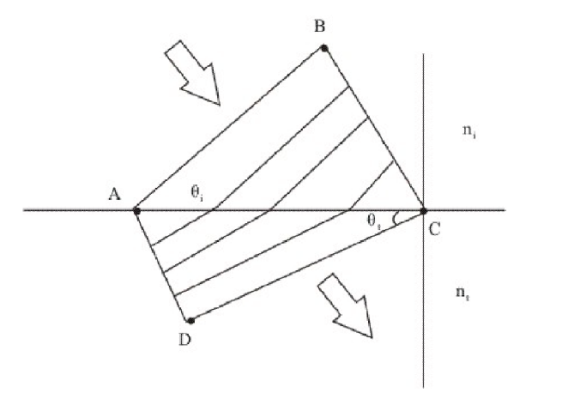

Figure 1: Incident and transmitted plane wavefronts at a flat interface between media with different indices of refraction ni and nt. The angles of incidence and of refraction are θi and θt.

**Problem 3)** **The Moon:** A ground-based telescope has a concave spherical mirror with radius of curvature of 8 meters. Find the location and diameter of the image of the Moon formed by this mirror. Draw a sketch to illustrate your result.

**Problem 4) The Moon and Jupiter:**

a) Using the Rayleigh criterion (spatial resolution in radians = 1.22 λ / D), estimate the angular resolution of the human eye at a wavelength of 500 nm. Assume that the diameter of the eye’s pupil is 5 mm.

b) Compare your answer in part a) to the angular diameters of the Moon and Jupiter seen from Earth.

c) What can you conclude about the ability of the human eye to resolve the Moon’s disk and Jupiter’s disk with the unaided eye?